Adam Clayton Powell Jr.

**From Wikipedia, the free encyclopedia**

https://en.wikipedia.org/wiki/Adam%20Clayton%20Powell%20Jr.  
Licensed under CC BY-SA 3.0:  
https://en.wikipedia.org/wiki/Wikipedia:Text_of_Creative_Commons_Attribution-ShareAlike_3.0_Unported_License

# Adam Clayton Powell Jr.

* *Adam Clayton Powell Jr. (November 29, 1908 – April 4, 1972) was a Baptist pastor and an American politician, who represented Harlem, New York City, in the United States House of Representatives (1945–1971).*
* *Following allegations of corruption, in 1967 Powell was excluded from his seat by Democratic Representatives-elect of the 90th United States Congress, but he was re-elected and regained the seat in the 1969 ruling by the Supreme Court of the United States in Powell v. McCormack.*

Adam Clayton Powell Jr. (November 29, 1908 – April 4, 1972) was a Baptist pastor and an American politician, who represented Harlem, New York City, in the United States House of Representatives (1945–1971). He was the first person of African-American descent to be elected from New York to Congress. in 1928 Oscar Stanton De Priest of Illinois was the first black person to be elected to Congress in the 20th century; Powell was the fourth.

Re-elected for nearly three decades, Powell became a powerful national politician of the Democratic Party, and served as a national spokesman on civil rights and social issues. He also urged United States presidents to support emerging nations in Africa and Asia as they gained independence after colonialism.

In 1961, after 16 years in the House, Powell became chairman of the Education and Labor Committee, the most powerful position held by an African American in Congress. As chairman, he supported the passage of important social and civil rights legislation under presidents John F. Kennedy and Lyndon B. Johnson. Following allegations of corruption, in 1967 Powell was excluded from his seat by Democratic Representatives-elect of the 90th United States Congress, but he was re-elected and regained the seat in the 1969 ruling by the Supreme Court of the United States in Powell v. McCormack. He lost his seat in 1970 to Charles Rangel and retired from electoral politics.

# Early years

* *(In his autobiography Adam By Adam, Powell says that his mother had partial German ancestry.)*
* *Sally never identified the father of Adam Clayton Powell Sr., born in 1865.*
* *Powell was born in 1908 in New Haven, Connecticut, the second child and only son of Adam Clayton Powell Sr. and Mattie Buster Shaffer, both born poor in Virginia and West Virginia, respectively.*

Powell was born in 1908 in New Haven, Connecticut, the second child and only son of Adam Clayton Powell Sr. and Mattie Buster Shaffer, both born poor in Virginia and West Virginia, respectively. His sister Blanche was 10 years older. His parents were of mixed race with African and European ancestry (and, according to his father, American Indian on his mother's side). (In his autobiography Adam By Adam, Powell says that his mother had partial German ancestry.) They and their ancestors were classified as mulatto in 19th-century censuses. Powell's paternal grandmother's ancestors had been free persons of color for generations before the Civil War. By 1908, Powell Sr. had become a prominent Baptist minister, serving as a pastor in Philadelphia, and being called as the lead pastor at a Baptist church in New Haven.

Powell Sr. had worked his way out of poverty and through Wayland Seminary, a historically black college, and postgraduate study at Yale University and Virginia Theological Seminary. In the year of his son's birth in New Haven, Powell Sr. was called as the pastor of the prominent Abyssinian Baptist Church in the Harlem neighborhood of New York City. He led the church for decades through major expansion, including fundraising for and the construction of an addition to accommodate the increased membership of the congregation during the years of the Great Migration, as many African Americans moved north from the South. That congregation grew to a community of 10,000 persons.

Due to his father's achievements, Powell grew up in a wealthy household in New York City. Because of his mixed European ancestry, Adam was born with hazel eyes, fair skin and blond hair, such that he could pass for white. However, he did not play with that racial ambiguity until college. He attended Townsend Harris High School, then studied at City College of New York before starting at Colgate University in upstate as a freshman. The four other African-American students at Colgate at the time were all athletes. For a time, Powell briefly passed as white, using his appearance to escape racial strictures at college. The other black students were dismayed to discover what he had done.  
Encouraged by his father to become a minister, Powell became more serious about his studies at Colgate, where he earned his bachelor's degree in 1930. After returning to New York, Powell began his graduate work and in 1931 earned an M.A. in religious education from Columbia University. He became a member of Alpha Phi Alpha, a fraternity started by and for blacks.

Later, apparently trying to bolster his black identity, Powell would say that his paternal grandparents were born into slavery. However, his paternal grandmother, Sally Dunning, was at least the third generation of free people of color in her family. In the 1860 census, she is listed as a free mulatto, as were her mother, grandmother, and siblings. Sally never identified the father of Adam Clayton Powell Sr., born in 1865. She appeared to have named her son after her older brother Adam Dunning, listed on the 1860 census as a farmer and the head of their household. In 1867 Sally Dunning married Anthony Bush, a mulatto freedman. All the family members were listed under the surname Dunning in the 1870 census.

The family changed its surname to Powell when they moved to Kanawha County, West Virginia, as part of their new life there. According to Charles V. Hamilton, a 1991 biographer of Powell, Anthony Bush "decided to take the name Powell as a new identity", and this is how they were recorded in the 1880 census.

Adam Jr.'s mother Mattie Buster Shaffer was also of mixed race, with African-American and German ancestry. Her parents had been slaves in Virginia and were freed after the American Civil War. Powell's parents married in West Virginia, where they met. Numerous freedmen had migrated there in the late 19th century for work.

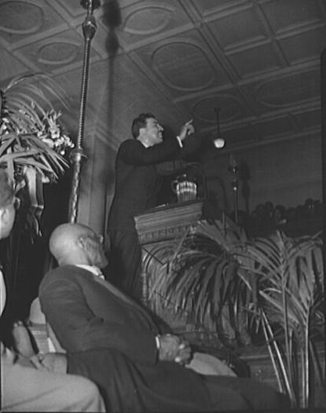  
*Powell addressing a citizens' committee mass meeting*

# Career

* *In 1938, Powell succeeded his father as pastor of the Abyssinian Baptist Church.*
* *For instance, during the 1939 New York World's Fair, Powell organized a picket line at the Fair's offices in the Empire State Building.*
* *Reporters and writers for the papers included influential African Americans such as Powell himself, Powell's sister-in-law and actress Fredi Washington, and journalist Marvel Cooke."*

After ordination, Powell began assisting his father with charitable services at the church and as a preacher. He greatly increased the volume of meals and clothing provided to the needy, and began to learn more about the lives of the working class and poor in Harlem.[citation needed]

During the Great Depression in the 1930s, Powell, a handsome and charismatic figure, became a prominent civil rights leader in Harlem. He recounted these experiences in a 1964 interview with Robert Penn Warren for the book Who Speaks for the Negro?. He developed a formidable public following in the community through his crusades for jobs and affordable housing. As chairman of the Coordinating Committee for Employment, Powell used numerous methods of community organizing to bring political pressure on major businesses to open their doors to black employees at professional levels. He organized mass meetings, rent strikes, and public campaigns to force companies, utilities, and Harlem Hospital, which operated in the community, to hire black workers at skill levels higher than the lowest positions, to which they had formerly been restricted by informal discrimination.

For instance, during the 1939 New York World's Fair, Powell organized a picket line at the Fair's offices in the Empire State Building. As a result, the Fair hired more black employees, increasing their numbers from about 200 to 732. In 1941, Powell led a bus boycott in Harlem, where blacks constituted the majority of passengers but held few of the jobs; the Transit Authority hired 200 black workers and set the precedent for more. Powell also led a fight to have drugstores operating in Harlem hire black pharmacists. He encouraged local residents to shop only where blacks were also hired to work. "Mass action is the most powerful force on earth," Powell once said, adding, "As long as it is within the law, it's not wrong; if the law is wrong, change the law."[citation needed]

In 1938, Powell succeeded his father as pastor of the Abyssinian Baptist Church.[citation needed] In 1942 he founded People's Voice, a newspaper designed for "a progressive African American audience, and it educated and enlightened readers on everything from local gatherings and events to U.S. civil rights issues to the political and economic struggles of the peoples of Africa. Reporters and writers for the papers included influential African Americans such as Powell himself, Powell's sister-in-law and actress Fredi Washington, and journalist Marvel Cooke." It also served as a mouthpiece for his views. After he was elected to Congress in 1944, other people led the paper, but it finally closed in 1948, after being accused of communist connections.

# Political career

# New York City Council

* *In 1941, with the aid of New York City's use of the single transferable vote, Powell was elected to the New York City Council as the city's first black Council member.*

In 1941, with the aid of New York City's use of the single transferable vote, Powell was elected to the New York City Council as the city's first black Council member. He received 65,736 votes, the third-best total among the six successful Council candidates.

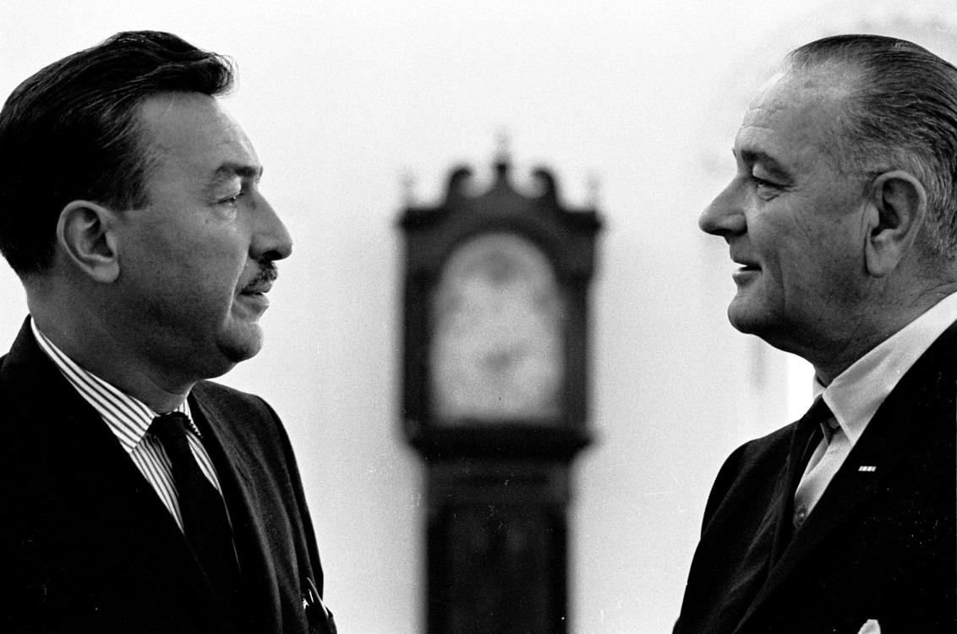  
*Powell with President Lyndon B. Johnson in the Oval Office, 1965.*

# Congress

* *He developed a strategy known as the "Powell Amendments".*
* *In 1944, Powell ran for the United States Congress on a platform of civil rights for African Americans: support for "fair employment practices, and a ban on poll taxes and lynching."*
* *As the historian Charles V. Hamilton wrote in his 1992 political biography of Powell,*
* *Powell was elected as a Democrat to represent the Congressional District that included Harlem.*

In 1944, Powell ran for the United States Congress on a platform of civil rights for African Americans: support for "fair employment practices, and a ban on poll taxes and lynching." Requiring poll taxes for voter registration and voting was a device used by southern states in new constitutions adopted from 1890 to 1908 to disenfranchise most blacks and many poor whites, in order to exclude them from politics. Poll taxes in the United States, together with the social and economic intimidation of Jim Crow laws, were maintained in the South into the 1960s to keep blacks excluded from politics and politically powerless.

Powell was elected as a Democrat to represent the Congressional District that included Harlem. He was the first black Congressman elected from New York State.

As the historian Charles V. Hamilton wrote in his 1992 political biography of Powell,

As one of only two black Congressmen (the other being William Levi Dawson) until 1955, Powell challenged the informal ban on black representatives using Capitol facilities previously reserved for white members. He took black constituents to dine with him in the "Whites Only" House restaurant. He clashed with the many segregationists from the South in his party. Since the turn of the 20th century, Southern Democrats had commanded a one-party system, as they had effectively disenfranchised most blacks from voting since the turn of the century and excluded them from the political system through barriers to voter registration and voting. The white Congressmen and Senators controlled all the seats allocated for the total population in the southern states, had established seniority, and commanded many important committee chairs in the House and Senate.

Powell worked closely with Clarence Mitchell Jr., the representative of the National Association for the Advancement of Colored People (NAACP) in Washington, D.C., to try to gain justice in federal programs. Biographer Hamilton described the NAACP as "the quarterback that threw the ball to Powell, who, to his credit, was more than happy to catch and run with it." He developed a strategy known as the "Powell Amendments". "On bill after bill that proposed federal expenditures, Powell would offer 'our customary amendment,' requiring that federal funds be denied to any jurisdiction that maintained segregation; Liberals would be embarrassed, Southern politicians angered." This principle would later become integrated into Title VI of the Civil Rights Act of 1964.

Powell was also willing to act independently; in 1956, he broke party ranks and supported President Dwight D. Eisenhower for re-election, saying the civil rights plank in the Democratic Party platform was too weak. In 1958, he survived a determined effort by the Tammany Hall Democratic Party machine in New York to oust him in the primary election. In 1960, Powell, hearing of planned civil rights marches at the Democratic Convention, which could embarrass the party or candidate, threatened to accuse Rev. Martin Luther King Jr. of having a homosexual relationship with Bayard Rustin unless the marches were cancelled. Rustin, one of King's political advisers, was an openly gay man. King agreed to cancel the planned events and Rustin resigned from the Southern Christian Leadership Conference.

# Global work

* *Powell returned to the United States to a warm bipartisan reception for his performance, and he was invited to meet with President Dwight D.*
* *Powell also paid attention to the issues of developing nations in Africa and Asia, making trips overseas.*
* *In 1955, against the State Department's advice, Powell attended the Asian–African Conference in Badung, Indonesia, as an observer.*

Powell also paid attention to the issues of developing nations in Africa and Asia, making trips overseas. He urged presidential policymakers to pay attention to nations seeking independence from colonial powers and support aid to them. During the Cold War, many of them sought neutrality between the United States and the Soviet Union. He made speeches on the House Floor to celebrate the anniversaries of the independence of nations such as Ghana, Indonesia, and Sierra Leone.

In 1955, against the State Department's advice, Powell attended the Asian–African Conference in Badung, Indonesia, as an observer. He made a positive international impression in public addresses that balanced his concerns of his nation's race relations problems with a spirited defense of the United States as a whole against Communist criticisms. Powell returned to the United States to a warm bipartisan reception for his performance, and he was invited to meet with President Dwight D. Eisenhower.[citation needed]

With this influence, Powell suggested to the State Department that the current manner of competing with the Soviet Union in the realm of fine arts such as international symphony orchestra and ballet company tours was ineffective. Instead, he advised that the United States should focus on the popular arts, such as sponsoring international tours of famous jazz musicians, which could draw attention to an indigenous American art form and featured musicians who often performed in mixed race bands. The State Department approved the idea. The first such tour with Dizzy Gillespie proved to be an outstanding success abroad and prompted similarly popular tours featuring other musicians for years.

# Committee chairmanship and legislation

* *In 1961, after 15 years in Congress, Powell advanced to chairman of the powerful United States House Committee on Education and Labor.*
* *Powell's committee proved extremely effective in enacting major parts of President Kennedy's "New Frontier" and President Johnson's "Great Society" social programs and the War on Poverty.*

In 1961, after 15 years in Congress, Powell advanced to chairman of the powerful United States House Committee on Education and Labor. In this position, he presided over federal social programs for minimum wage and Medicaid (established later under Johnson); he expanded the minimum wage to include retail workers; and worked for equal pay for women; he supported education and training for the deaf, nursing education, and vocational training; he led legislation for standards for wages and work hours; as well as for aid for elementary and secondary education, and school libraries. Powell's committee proved extremely effective in enacting major parts of President Kennedy's "New Frontier" and President Johnson's "Great Society" social programs and the War on Poverty. It successfully reported to Congress "49 pieces of bedrock legislation", as President Johnson put it in an May 18, 1966, letter congratulating Powell on the fifth anniversary of his chairmanship.

Powell was instrumental in passing legislation that made lynching a federal crime, as well as bills that desegregated public schools. He challenged the Southern practice of charging Blacks a poll tax to vote. Poll taxes for federal elections were prohibited by the 24th Amendment, passed in 1964. Voter registration and electoral practices were not changed substantially in most of the South until after passage of the Voting Rights Act of 1965, which provided federal oversight of voter registration and elections, and enforcement of the constitutional right to vote. In some areas where discrimination was severe, such as Mississippi, it took years for African Americans to register and vote in numbers related to their proportion in the population, but they have since maintained a high rate of registration and voting.

# Political controversy

* *In June 1969, in Powell v. McCormack, the Supreme Court of the United States ruled that the House had acted unconstitutionally when it excluded Powell, as he had been duly elected by his constituents.*
* *In November 1968, Powell was re-elected.*
* *In January 1967, the House Democratic Caucus stripped Powell of his committee chairmanship.*
* *He sued in Powell v. McCormack to retain his seat.*

By the mid-1960s, Powell was increasingly being criticized for mismanaging his committee's budget, taking trips abroad at public expense, and missing meetings of his committee. When under scrutiny by the press and other members of Congress for personal conduct—he had taken two young women at government expense with him on overseas travel—he responded:

Opponents led criticism in his District, where his refusal to pay a 1963 slander judgment made him subject to arrest; he also spent increasing amounts of time in Florida.

In January 1967, the House Democratic Caucus stripped Powell of his committee chairmanship. The full House refused to seat him until completion of an investigation by the Judiciary Committee. Powell urged his supporters to "keep the faith, baby," while the investigation was under way. On March 1, the House voted 307 to 116 to exclude him. Powell said, "On this day, the day of March in my opinion, is the end of the United States of America as the land of the free and the home of the brave."

Powell won the Special Election to fill the vacancy caused by his exclusion, but he did not take his seat, as he was filing a separate suit. He sued in Powell v. McCormack to retain his seat. In November 1968, Powell was re-elected. On January 3, 1969, he was seated as a member of the 91st Congress, but he was fined $25,000 and denied seniority. In June 1969, in Powell v. McCormack, the Supreme Court of the United States ruled that the House had acted unconstitutionally when it excluded Powell, as he had been duly elected by his constituents.

Powell's increasing absenteeism was noted by constituents, which contributed, in June 1970, to his defeat in the Democratic primary for reelection to his seat by Charles B. Rangel. Powell failed to garner enough signatures to get on the November ballot as an Independent, and Rangel won that (and following) general elections. In the fall of 1970, Powell moved to his retreat on Bimini in The Bahamas, also resigning as minister at the Abyssinian Baptist Church.

# Marriage and family

* *They had a son, whom they named Adam Clayton Powell Diago, using the mother's surname, according to Latino tradition.*
* *They had a son named Adam Clayton Powell III.*
* *Adam Clayton Powell IV, also known as A.C. Powell IV, was elected to the New York City Council in 1991 in a special election; he served for two terms.*
* *Like Powell, she was of mixed race.*

In 1933, Powell married Isabel Washington (1908–2007), an African-American singer and nightclub entertainer. Like Powell, she was of mixed race. She was the sister of actress Fredi Washington. Powell adopted Washington's, son Preston, from her first marriage.

After their divorce, in 1945, Powell married the singer Hazel Scott. They had a son named Adam Clayton Powell III. In the early 21st century, Adam Clayton Powell III became Vice Provost for Globalization at the University of Southern California.

Powell divorced again, and in 1960 married Yvette Flores Diago from Puerto Rico. They had a son, whom they named Adam Clayton Powell Diago, using the mother's surname, according to Latino tradition. In 1980, this son changed his name to Adam Clayton Powell IV (dropping "Diago" from his name) when he moved to the mainland of the United States from Puerto Rico to attend Howard University. Adam Clayton Powell IV, also known as A.C. Powell IV, was elected to the New York City Council in 1991 in a special election; he served for two terms. He also was elected as a New York state Assemblyman (D-East Harlem) for three terms and had a son named Adam Clayton Powell V. In 1994, and again in 2010, Adam Clayton Powell IV unsuccessfully challenged incumbent Rep. Charles B. Rangel for the Democratic nomination in his father's former congressional district.

# Family scandal

* *In 1967, a U.S. Congressional committee subpoenaed Yvette Diago, the former third wife of Powell Jr. and the mother of Adam Clayton Powell IV.*
* *Yvette Diago admitted to the committee that she had been on the Congressional payroll of her former husband, Adam Clayton Powell Jr., from 1961 until 1967, although she had moved back to Puerto Rico in 1961.*

In 1967, a U.S. Congressional committee subpoenaed Yvette Diago, the former third wife of Powell Jr. and the mother of Adam Clayton Powell IV. They were investigating potential "theft of state funds" related to her having been on Powell Jr.'s payroll but doing no work. Yvette Diago admitted to the committee that she had been on the Congressional payroll of her former husband, Adam Clayton Powell Jr., from 1961 until 1967, although she had moved back to Puerto Rico in 1961. As reported by Time magazine, Yvette Diago had continued living in Puerto Rico and "performed no work at all," yet was kept on the payroll. Her salary was increased to $20,578 and she was paid until January 1967, when she was exposed and fired.

# Death

* *In April 1972, Powell became gravely ill and was flown to a Miami hospital from his home in Bimini.*
* *After his funeral at the Abyssinian Baptist Church in Harlem, his son, Adam III, poured his ashes from a plane over the waters of Bimini.*

In April 1972, Powell became gravely ill and was flown to a Miami hospital from his home in Bimini. He died there on April 4, 1972, at the age of 63, from acute prostatitis, according to contemporary newspaper accounts. After his funeral at the Abyssinian Baptist Church in Harlem, his son, Adam III, poured his ashes from a plane over the waters of Bimini.

# Legacy

* *One of the landmarks along this street is the Adam Clayton Powell Jr. State Office Building, named for Powell in 1983.*
* *In 2011, the new Adam Clayton Powell Jr. Paideia Academy opened in Chicago's South Shore neighborhood.*
* *Seventh Avenue north of Central Park through Harlem has been renamed as Adam Clayton Powell Jr. Boulevard.*

Seventh Avenue north of Central Park through Harlem has been renamed as Adam Clayton Powell Jr. Boulevard. One of the landmarks along this street is the Adam Clayton Powell Jr. State Office Building, named for Powell in 1983.

In addition, two New York schools were named after him, PS 153, at 1750 Amsterdam Ave., and a middle school, IS 172 Adam Clayton Powell Jr. School of Social Justice, at 509 W. 129th St. It closed in 2009. In 2011, the new Adam Clayton Powell Jr. Paideia Academy opened in Chicago's South Shore neighborhood.

# Representation in other media

* *Powell was the subject of the 2002 cable television film Keep the Faith, Baby, starring Harry Lennix as Powell and Vanessa Williams as his second wife, jazz pianist Hazel Scott.*
* *The film's producers were Geoffrey L. Garfield, Powell IV's long-time campaign manager; Monty Ross, a confidant of Spike Lee; son Adam Clayton Powell III; and Hollywood veteran Harry J. Ufland.*

Powell was the subject of the 2002 cable television film Keep the Faith, Baby, starring Harry Lennix as Powell and Vanessa Williams as his second wife, jazz pianist Hazel Scott. The film debuted on February 17, 2002, on premium cable network Showtime. It garnered three NAACP Image Award nominations for Outstanding Television Movie, Outstanding Actor in a Television Movie (Lennix), and Outstanding Actress in a TV Movie (Williams). It won two National Association of Minorities in Cable (NAMIC) Vision Awards for Best Drama and Best Actor in a Television Film (Lennix), the International Press Association's Best Actress in a Television Film Award (Williams), and Reel.com's Best Actor in a Television Film (Lennix). The film's producers were Geoffrey L. Garfield, Powell IV's long-time campaign manager; Monty Ross, a confidant of Spike Lee; son Adam Clayton Powell III; and Hollywood veteran Harry J. Ufland. The film was written by Art Washington and directed by Doug McHenry.

# Works

* *(1971) Adam by Adam: The Autobiography of Adam Clayton Powell Jr.*

(1945) Marching Blacks, An Interpretive History of the Rise of the Black Common Man

(1962) The New Image in Education: A Prospectus for the Future by the Chairman of the Committee on Education and Labor

(1967) Keep the Faith, Baby!

(1971) Adam by Adam: The Autobiography of Adam Clayton Powell Jr.

# See also

* *Adam Clayton Powell, a 1989 documentary film*

Adam Clayton Powell, a 1989 documentary film

List of African-American United States Representatives

Timeline of the civil rights movement

Unseated members of the United States Congress

List of federal political scandals in the United States

List of United States representatives expelled, censured, or reprimanded

# Notes

# References

# Further reading

* *Hamilton, Charles V. Adam Clayton Powell Jr.: The Political Biography of an American Dilemma (Atheneum, 1991).*
* *King of the Cats: The Life and Times of Adam Clayton Powell, Jr. (Houghton Mifflin Harcourt, 1993)*
* *"From Different Liberal Perspectives: Fiorello H. La Guardia, Adam Clayton Powell Jr., and Civil Rights in New York City, 1941-1943."*

Capeci, Dominic J. "From Different Liberal Perspectives: Fiorello H. La Guardia, Adam Clayton Powell Jr., and Civil Rights in New York City, 1941-1943." Journal of Negro History (1977): 160-173. in JSTOR

Hamilton, Charles V. Adam Clayton Powell Jr.: The Political Biography of an American Dilemma (Atheneum, 1991).

Haygood, Wil. King of the Cats: The Life and Times of Adam Clayton Powell, Jr. (Houghton Mifflin Harcourt, 1993)

Paris, Peter J. Black Leaders in Conflict: Joseph H. Jackson, Martin Luther King Jr., Malcolm X, Adam Clayton Powell Jr. (Pilgrim Press, 1978)

# Primary sources

* *Powell Jr, Adam Clayton.*
* *Adam by Adam: The Autobiography of Adam Clayton Powell Jr (Kensington Books, 2002)*

Powell Jr, Adam Clayton. Adam by Adam: The Autobiography of Adam Clayton Powell Jr (Kensington Books, 2002)

# External links

* *"Adam Clayton Powell Jr. (id: P000477)".*
* *United States House of Representatives biography of Powell*
* *Rushing, Lawrence, "The Racial Identity of Adam Clayton Powell Jr: A Case Study in Racial Ambivalence and Redefinition", Afro-Americans in New York Life and History, January 1, 2010*
* *Speech by Adam Clayton Powell given on April 10, 1969.*
* *Booknotes interview with Charles Hamilton on Adam Clayton Powell Jr.: The Political Biography of an American Dilemma, January 5, 1992.*

United States Congress. "Adam Clayton Powell Jr. (id: P000477)". Biographical Directory of the United States Congress.

United States House of Representatives biography of Powell

Booknotes interview with Charles Hamilton on Adam Clayton Powell Jr.: The Political Biography of an American Dilemma, January 5, 1992.

Speech by Adam Clayton Powell given on April 10, 1969. Audio recording, from The University of Alabama's Emphasis Symposium on Contemporary Issues

Rushing, Lawrence, "The Racial Identity of Adam Clayton Powell Jr: A Case Study in Racial Ambivalence and Redefinition", Afro-Americans in New York Life and History, January 1, 2010